Research Guide: How to Search for Federal Central District Cases
(The Federal Central District covers San Bernardino and Riverside Counties)
Law Library for San Bernardino County
Research Guide, www.sblawlibrary.org, (909) 885-3020.

How do I search for local Central District Cases for San Bernardino and Riverside Counties?

Step 1: Using your PACER account information login at www.pacer.gov.

Step 2: You should be on a page called Individual Court PACER Sites. Find the U.S. District Courts and click on California Central – ECF.

Step 3: You will now be on the Central Court case management site. Click on the Document Filing System link located at the middle of the screen.

Step 4: You are now on the Document Filing System for the Central District of California. This includes Los Angeles, Riverside, and San Bernardino Counties.

Step 5: To search for your case, select Query located at the top left of your page.

Practical Pointer: You can go directly to the Central District Document Filing System instead of logging in at www.pacer.gov. The following link will allow you to log in directly to the Central District: https://ecf.cacd.uscourts.gov/cgi-bin/login.pl.

What if I do not have my case number? You can still search for your case but you will need to have some criteria to search for. For example you can search by case dates and case subjects. Once you find your case it is a good idea to write down the case number for future inquiries. This will help save you time and reduce the amount of searches that count against your quarterly threshold of $10.

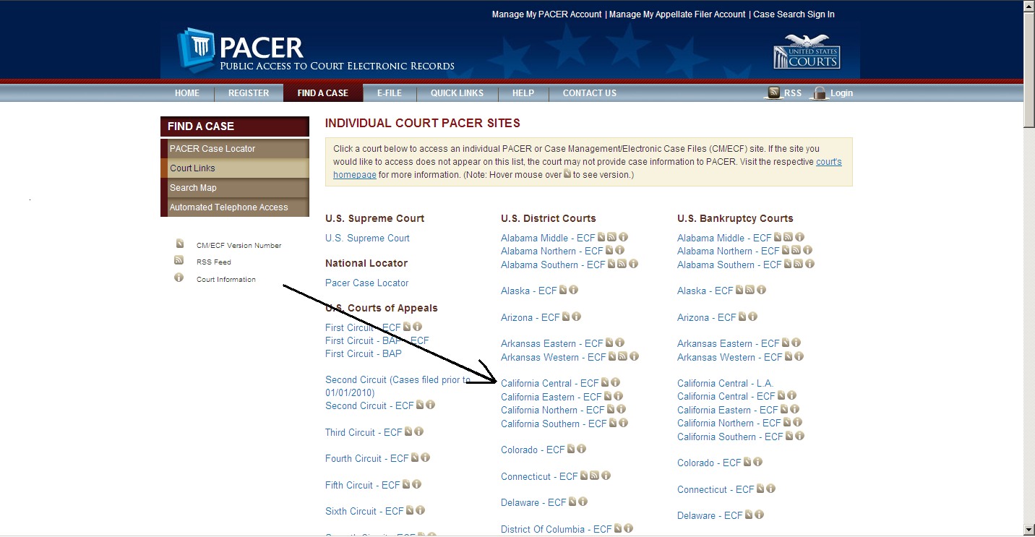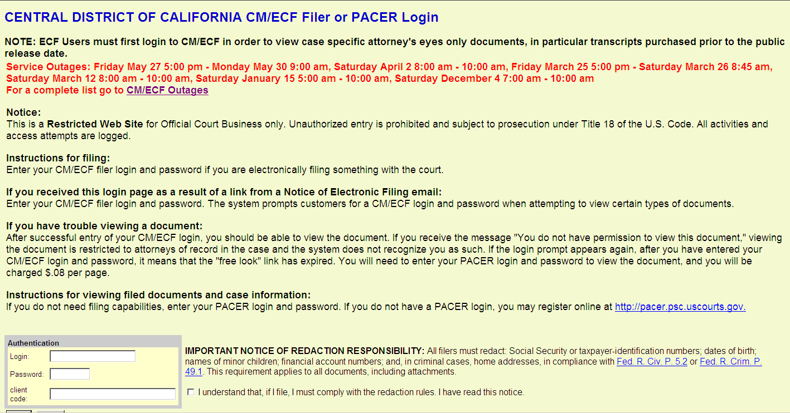
(Step 2) (Step 4)



