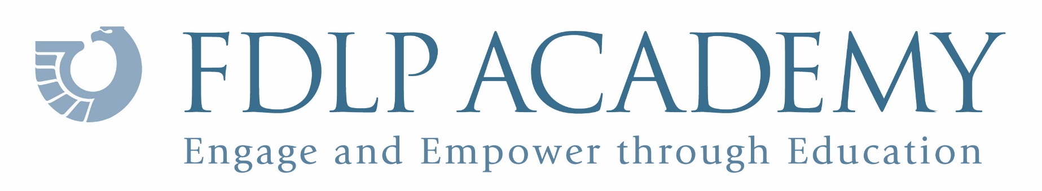

U.S. Government Publishing Office

Certificate of Education

This is to certify that

Viewed the one-hour webinar held June 11, 2020:
Resources across the Generations:
Government Resources to Cover Everyone from
The Greatest Generation to Gen Z

